**Procedure:** All 5 disks will be labeled, then have thier radius measured using a meter stick, after which they will be weighed on a digtal scale to collect data regarding their mass. Then their thickness was measured by using a meter stick. After the data regarding the radius and mass was put into a table, which was used to create graph 1 through sheets. After which the graph was linearlized by using r2 as the x value as it is the only value that isn’t constant to create graph2 after imputing it into sheets and creating a graph.

**Purpose Statement:**

Given “disks” of different radii, determine the relationship between the mass and radius of the disks through graphical method.

In using graphical method, we will learn about linearization and the use of it to create a mathematical model.

**Equations:**

1. p=m/v
2. m=p*v
3. V=a*h
4. m=p*a*h
5. m=p*pi*r^2*h

**Data Table:**

|  | Height | Radius (cm) | Mass(g) |  | Radius^2 (cm^2) |
| --- | --- | --- | --- | --- | --- |
| Disk 1 | 0.14 mm | 2.38 | 0.08 |  | 5.66 |
| Disk 2 | 3.15 | 0.14 |  | 9.92 |
| Disk 3 | 3.80 | 0.24 |  | 14.44 |
| Disk 4 | 5.40 | 0.38 |  | 29.16 |
| Disk 5 | 6.85 | 0.71 |  | 46.92 |

**Graph 1**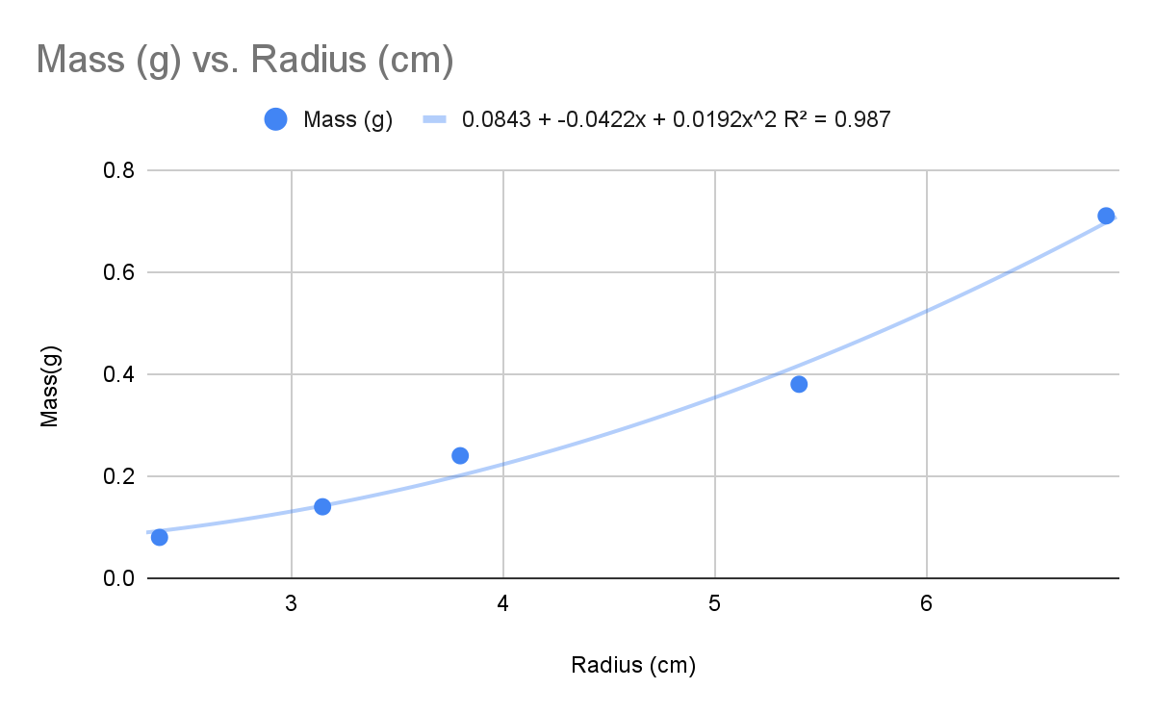

**Graph 2**

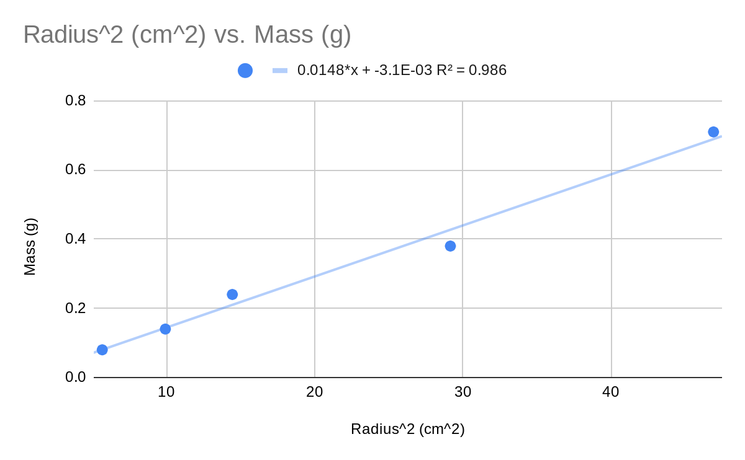

y = 0.0148x - 3.1*10-3

**Analysis Questions:**

**1)** What is the independent variable in your y = mx +b formula? The independent variable on the formula would be r2 it is the only constant variable across all the formulas.

As the density is equal to ⍴ = m/v and as density is constant m can be m = ⍴v, and as v = a*h, and expanded it would be v = π*r2*h, so when substituted into the equation for mass m = ⍴*π*r2*h, and as all three values density (all discs are aluminum), π (constant), h (all are the same thickness) are constant it would make r2 the only value that changes between all 5 discs making it the independent variable.

---------------------------------------------------------------------------------------------------------------------

**2)** What does the slope represent in your y = mx +b formula? Show dimensionally that indeed that is what your slope represents and that the formula is valid dimensionally.

The slope represents ⍴πh. As the equation for density is ⍴ = m/v and as ⍴ is constant it allows for m = πv, which allows for it to be rewritten as m = ⍴*π*h*r2 and as m is the y value and r2 is the x value it can be further rewritten as y = ⍴*π*h*x making ⍴πh the slope. And the formula is m = ⍴*π*h*r2  is demensionally valid as

m = (m(πr2h)-1)(h)(r2) which is M = (M(L2L)-1)(L)(L2), M = M (L-3)(L3), M = M

---------------------------------------------------------------------------------------------------------------------

**3)** Should the "b" in your y = mx + b formula be zero? Explain your answer.

Yes as the independent variable is r2 and as a disc with the radius of 0 should also have a mass of 0 (dependent variable).

---------------------------------------------------------------------------------------------------------------------

**4)** Measure/estimate the "thickness" of your cylinders. Use that value to find the experimental density of your cylinders. Find a percent difference between your found density and the actual density. The actual material is aluminum.

The thickness value of the cylinders was 0.14 mm (0.014 cm), with a slope of 0.0148 (⍴*π*h), ⍴ = 0.0148/π*(0.014 cm), ⍴ = 0.336 g/cm3, compared to the real density of aluminum which is 2.3/cm3. |0.336-2.3|/2.3 *100, 85.39% error.

---------------------------------------------------------------------------------------------------------------------

**5)** errors. Make sure you explain why your number is bigger or smaller than (if positive or negative difference.)

My number is substantially smaller as when using the line of best fit the value for the y-intercept is not 0 i.e. when r2 = 0 the value for mass is not 0 which is not possible in real life meaning that that decrepency coupled with the fact that the measuring techniques through using a meter stick to estimate the thickness and radius of the disks would also be less accurate than proper electronic measurements in a lab.

---------------------------------------------------------------------------------------------------------------------

**Synthesis Questions:**

**1)** In this experiment, if we had used disks with a greater thickness, would the slope

of your best fit line have been different? Would your experimental value for density be

the same? Explain.

If disks of greater thickness was used the value for slope would be different as previously mentioned when the expanded equation for mass which is m = ⍴*π*h*r2

is rewritten would be y = ⍴*π*h(x), and which would make ⍴*π*hthe slope and as h is a part of the slope value and if it were greater it would make the slope greater. However, the density would stay the same as the material would remain unchanged as if the height was greater it would also cause the mass to increase and it would cancel out when solving for the density.

---------------------------------------------------------------------------------------------------------------------

**2)** How would your graph of m versus r2 be different if you had used disks of the same

thickness, but made out of steel? Draw a second line on your m versus r2 plot that

represents disks made of steel.

If you had used disks made of steel but of the same thickness, you would have disks of a greater density than that of the aluminum graph. Which would cause the graph mass vs r2 to be above that of the one made of aluminum.



---------------------------------------------------------------------------------------------------------------------

**3)** Another group of students has acquired data for the exact same experiment;

however, their disks are made of an unknown material that they are trying to

determine. The group's m versus r2 data produced a line of best fit with slope equal to

122 kg/m2. Each disk they measured had the same 0.5 cm thickness. Calculate the

density of the unknown material and use the table below to help determine what

material their disks are made of.

m = ⍴*π*h*r2, y = ⍴*π*h(x), 122kg/m2 = ⍴*π*0.005, 122/0.005π = ⍴, ⍴ = 7,766.76 kg/m3, 7,766.761kg/m3 * 1000g/kg = 7,766,761g/m3 * 1*106 cm3/m3 = 7,766,761g/1*106, 7.766761g/cm3 approx 7.8 = Iron

---------------------------------------------------------------------------------------------------------------------

**Multiple Choice:**

1. - E
   1. m = ⍴*π*h*r2, C = 2πr, C/2π = r, m = ⍴*π*h*(C/2π)2, m = ⍴*π*h*C2/4π2, ⍴*h*C2/4π, ⍴h/4π(x),
2. - C
   1. ⍴ = m/v and as density is constant m can be m = ⍴v, and as v = 4/3πr3, so when substituted into the equation for mass m = ⍴*π*4/3πr3 and the only non constant is r3 making it the only value that would lineralize the graph

**Graphs:** [Lab 1 Graphs](https://docs.google.com/spreadsheets/d/1ve7x10WCs20Ljm9pcA0WV0ngxfo5_7_TJxtwPe2HV4k/edit?usp=sharing)